**Name: Chirag Bhagwan Vartak**

**Qualification: Bsc IT**

**Experience: 4 Years**

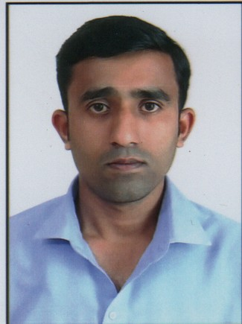**Photo:**

**Name: Sonali Kondu Dalvi**

**Qualification: Hsc COPA**

**Experience: 3 Years**

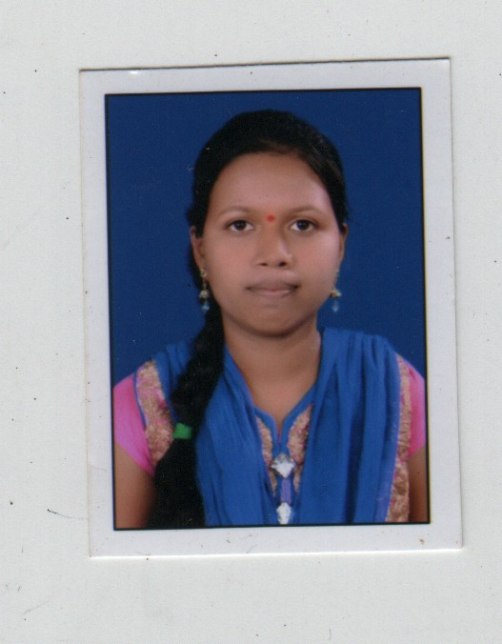**Photo:**